Dear residents,  
  
Due to an influx of non-residents using our pools (this does not include guests) I have decided to implement a new system to make sure that only residents and guests are using our pools.  
  
Effective immediately, all residents and their guests will be required to wear wristbands while they are in the pool area. Each unit owner will receive two blue TGCA bands. Guest bands (yellow) are also available upon request. All guest band requests require 48 hour notice. Guest wristbands must be returned when your guest leaves.

Wristbands will be handed out by Mark and I on the following days and times:   
  
**Thursday, November 14th from 11:00 a.m. - 12:00 p.m. maintenance shop**  
  
**Tuesday, November 19th from 1:00 p.m. - 2:00 p.m. maintenance shop**

**Saturday, November 23rd from 11:00 a.m. - 12:00 p.m. Clubhouse**

In order to accommodate everyone, more dates and times will be set up soon.

I understand that this process will take some time so let's all work together.

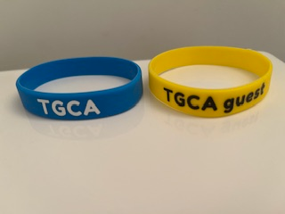

Thank you for your cooperation in helping to keep TGCA a safe and enjoyable place to live.

Ceil Roy, President