**ADDITIONAL NEW POOL WRISTBAND HANDOUT DATES**

**Monday, November 18th from 11:00 a.m. – 12:00 p.m. maintenance shop**

**Tuesday, November 19th from 1:00 p.m. - 2:00 p.m. maintenance shop**

**Wednesday, November 20th from 11:00 – 12:00 p.m. maintenance shop**

**Thursday, November 21st from 11:00 a.m. – 12:00 p.m. maintenance shop**

**Friday, November 22nd from 11:00 a.m. – 12:00 p.m. maintenance shop**

**Saturday, November 23rd from 11:00 a.m. - 12:00 p.m. Clubhouse**

**I understand that this process will take some time so let's all work together.**

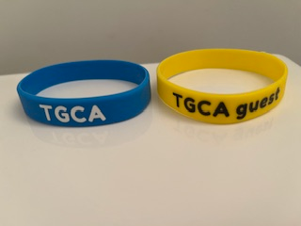

**Thank you for your cooperation in helping to keep TGCA a safe and enjoyable place to live.**

**Ceil Roy, President**